What are some common Data Preparation Operations you would use for Time Series Data?
Answer
Some data preparation operations which can be used are:
- Parsing time series information from various sources and formats.
- Generating sequences of fixed-frequency dates and time spans.
- Manipulating and converting date times with time zone information.
- Resampling or converting a time series to a particular frequency.
- Performing date and time arithmetic with absolute or relative time increments.

What are some examples of Time-Series Data which can be Mined?
Answer
Some examples of such data are as follows:
- Sensor data: Sensor data is often collected by a wide variety of hardware and other monitoring devices. Typically, this data contains continuous readings about the underlying data objects. For example, environmental data is commonly collected with different kinds of sensors that measure temperature, pressure, humidity, and so on. Sensor data is the most common form of time series data.
- Medical devices: Many medical devices such as an electrocardiogram (ECG) and electroencephalogram (EEG) produce continuous streams of time series data. These represent measurements of the functioning of the human body, such as the heartbeat, pulse rate, blood pressure, etc. Real-time data is also collected from patients in intensive care units (ICU) to monitor their condition.
- Financial market data: Financial data, such as stock prices, is often temporal. Other forms of temporal data include commodity prices, industrial trends, and economic indicators.

What are some real-world applications of Time-Series Forecasting?

Answer
- Time-Series in Financial and Business Domain: Time series analysis and forecasting essential processes for explaining the dynamic and influential behavior of financial markets. Via examining financial data, an expert can predict required forecasts for important financial applications in several areas such as risk evolution, option pricing & trading, portfolio construction, etc.
- Time-Series in Medical Domain: Medical instruments like electrocardiograms, and electroencephalograms are used to diagnose cardiac conditions, and measure electrical activity in the brain, respectively. These inventions made more opportunities for medical practitioners to deploy time series for medical diagnosis.
- Time-Series in Astronomy: Being specific in its domain, astronomy hugely relies on plotting objects, trajectories, and accurate measurements, and due to the same, astronomical experts are proficient in time series in calibrating instruments and studying objects of their interest. In the past century, time series analysis was used to discover variable stars that are used to surmise stellar distances, and observe transitory events such as supernovae to understand the mechanism of the changing of the universe with time.

Why does a Time Series have to be Stationary?
Answer
Stationarity is important because, in its absence, a model describing the data will vary in accuracy at different time points. As such, stationarity is required for sample statistics such as means, variances, and correlations to accurately describe the data at all time points of interest.
Looking at the time series plots below, you can (hopefully) see how the mean and variance of any given segment of time would do a good job representing the whole stationary time series but a relatively poor job representing the whole non-stationary time series. For instance, the mean of the non-stationary time series is much lower from
600<t<800 and its variance is much higher in this range than in the range from 200<t<400
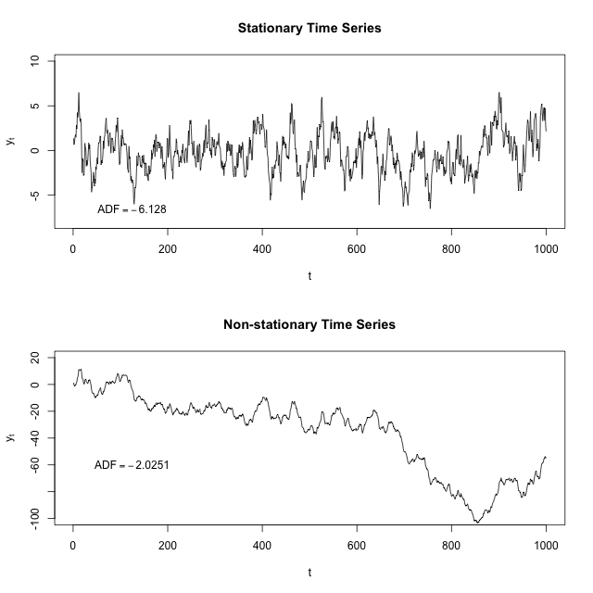
What quantities are we typically interested in when we perform statistical analysis on a time series? We want to know
- Its expected value,
- Its variance, and
- The correlation between values 𝑠ss periods apart for a set of 𝑠ss values.
How do we calculate these things? Using a mean across many time periods.
The mean across many time periods is only informative if the expected value is the same across those time periods. If these population parameters can vary, what are we really estimating by taking an average across time?
(Weak) stationarity requires that these population quantities must be the same across time, making the sample average a reasonable way to estimate them.

Can Non-Sequential Deep Learning Models outperform Sequential Models in Time-Series Forecasting?
Answer
- Yes, non-sequential deep learning models like CNN can outperform sequential models like RNN.
- Even though there are no big differences in terms of results there are some nice properties that CNN based models offer such as, parallelism, stable gradients, and low training memory footprint.
- So depending on what type of properties you want your model to have, architectures can be chosen accordingly.

Compare some Forecasting Techniques for Stationary and Non-stationary Time-Series
Answer
- Time-series data which exhibit weak stationarity properties, will have the mean and covariance between approximately adjacent time series values be non-zero and constant over time. This is referred to as covariance stationarity.
- This kind of weak stationarity can be assessed relatively easily and is also useful for forecasting models that are dependent on specific parameters such as the mean and covariance.
- In other nonstationary series, the average value of the series can be described by a trend-line that is not necessarily horizontal, as required by a stationary series. Periodically, the series will deviate from the trend line, possibly because of some changes in the generative process, and then return to the trend line. This is referred to as a trend stationary series.
- Nonstationary data can be converted to stationary series for forecasting. One method is called differencing.
- In differencing, the time series value Y_i is replaced by the difference between it and the previous value. Therefore, the new value y'_i
$yi′​=yi​−yi−1​$
If the series is stationary after differencing, then an appropriate model for the data is
$yi+1​=yi​+ei+1​$
Here, ei+1 corresponds to white noise with zero mean. A differenced time series would have t-1 values for a series of length t because it is not possible for the first value to be reflected in the transformed series.
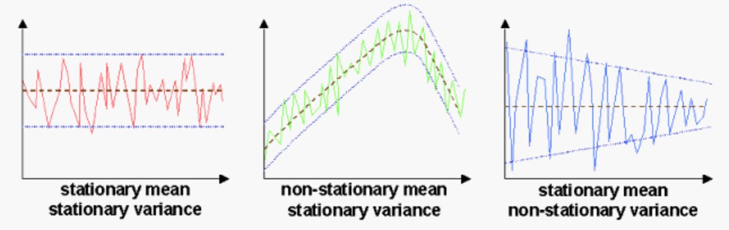

How would you compare the two Time Series shown below?
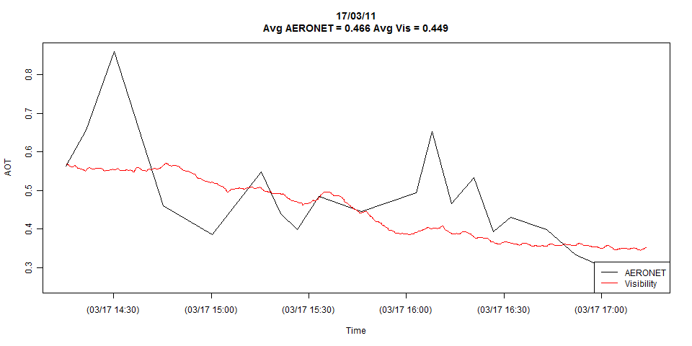
Answer
- The plot appears to obscure what may be a crucial difference between these series: they might be sampled at different frequencies. The black line (Aeronet) seems to be sampled only about 20 times and the red line (Visibility) hundreds of times or more.
- Another critical factor may be the regularity of sampling, or lack thereof: the times between Aeronet observations appear to vary a little. In general, it helps to erase the connecting lines and display only the points corresponding to actual data, so that the viewer can determine these things visually.
- After you have a common frequency of measurement, then a common model should be identified that would reasonably describe each series separately. This might be an ARIMA model or a multiply-trended Regression Model with possible Level Shifts or a composite model integrating both memory (ARIMA) and dummy variables. This common model could be estimated globally and separately for each of the two series and then one could construct an F test to test the hypothesis of a common set of parameters.

If your Time-Series Dataset is very long, what architecture would you use?
Answer
- If the dataset for time-series is very long, LSTMs are ideal for it because it can not only process single data points, but also entire sequences of data. A time-series being a sequence of data makes LSTM ideal for it.
- For an even stronger representational capacity, making the LSTM's multi-layered is better.
- Another method for long time-series dataset is to use CNNs to extract information.

What is a Moving Average Process? Give some Real-life Examples.
Answer
- In time-series analysis, moving-average process, is a common approach for modeling univariate time series. The moving-average model specifies that the output variable depends linearly on the current and various past values of a stochastic term.
- Time-series for which a moving average process of order q is given by,
$yt​=i=1∑q​θi​ϵt−i​+ϵt​, where ϵt​≈N(0,σ2)$
- An application of this is misspecification. For example, let y be grocery sales and ϵ be an unobserved (to the analyst) coupon campaign that varies in intensity over time. At any point in time, there may be several "vintages" of coupons circulating as people use them, throw them away, and receive new ones. Shocks can also have persistent (but gradually weakening) effects. Take natural disasters or simply bad weather. Battery sales go up before the storm, then fall during, and then jump again as people realize that disaster kits may be a good idea for the future.

What process do you go through to design a Neural Network for Time-Series Forecasting?
Answer
Let's assume you have monthly data recorded over several years, so you have 36 values. Let's also assume that you only care about predicting one month (value) in advance.
- Exploratory data analysis: Apply some of the traditional time series analysis methods to estimate the lag dependence in the data (e.g. auto-correlation and partial auto-correlation plots, transformations, differencing). Let's say that you find a given month's value is correlated with the past three month's data but not much so beyond that.
- Partition your data into training and validation sets: Take the first 24 points as your training values and the remaining points as the validation set.
- Create the neural network layout: You'll take the past three month's values as inputs and you want to predict the next month's value. So, you need a neural network with an input layer containing three nodes and an output layer containing one node. You should probably have a hidden layer with at least a couple of nodes. Unfortunately, picking the number of hidden layers, and their respective number of nodes, is not something for which there are clear guidelines. I'd start small, like 3:2:1.
- Create the training patterns: Each training pattern will be four values, with the first three corresponding to the input nodes and the last one defining what the correct value is for the output node. For example, if your training data are values $x_1, x_2, ..., x_\{24\}x1​,x2​,...,x24​,$
then;
  - pattern1: x_1, x_2, x_3, x_4
pattern2: x_2, x_3, x_4, x_5
pattern21: x_{21}, x_{22}, x_{23}, x_{24}
5. Train the neural network on these patterns.
- Test the network on the validation set (months 25 - 36): Here you will pass in the three values the neural network needs for the input layer and see what the output node gets set to. So, to see how well the trained neural network can predict month 32's value you will pass in values for months 29, 30 and 31.

